1) **Steps for creating Target Groups**

**A.** **Go to AWS console in AWS interface left bottom side down Load Balancing is their ..**

**B. In That select Target Groups..**

**C. Next select the option create Target Group..**

**D. Add credentials in required section**

**E. Specify group details as shown in below images…**

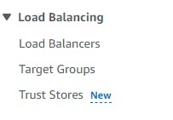

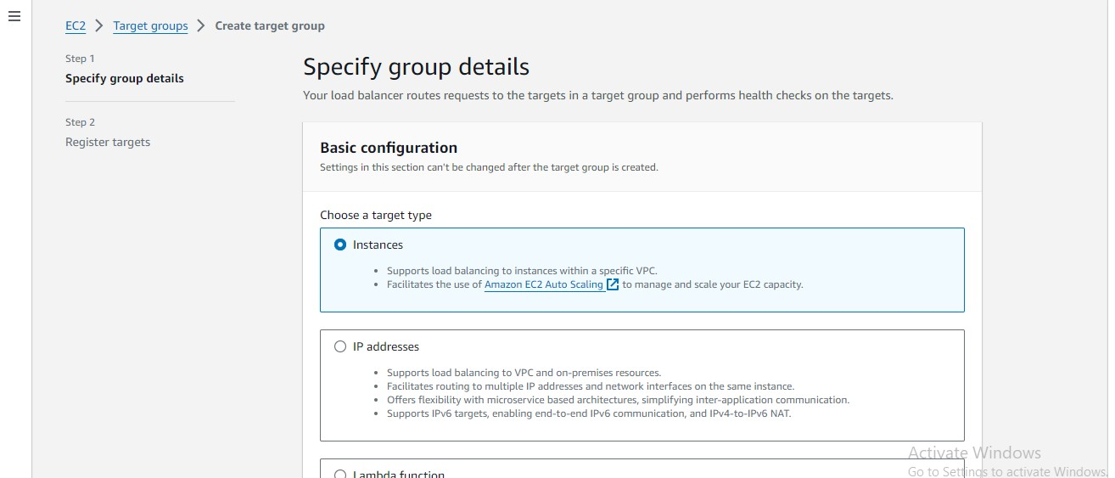

**2) Adding specified details for required section…**

**A. Below images shown details..**

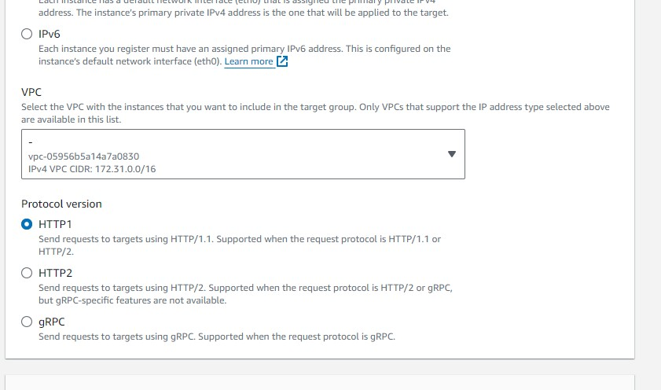

**3) Add target group name in required fields..**

**A. Next select the option Create target group….**

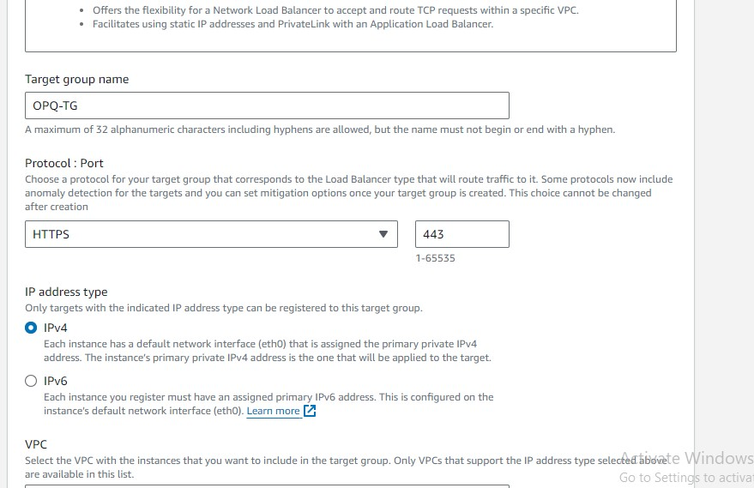

**4) Successfully created the target group QPO-TG..**

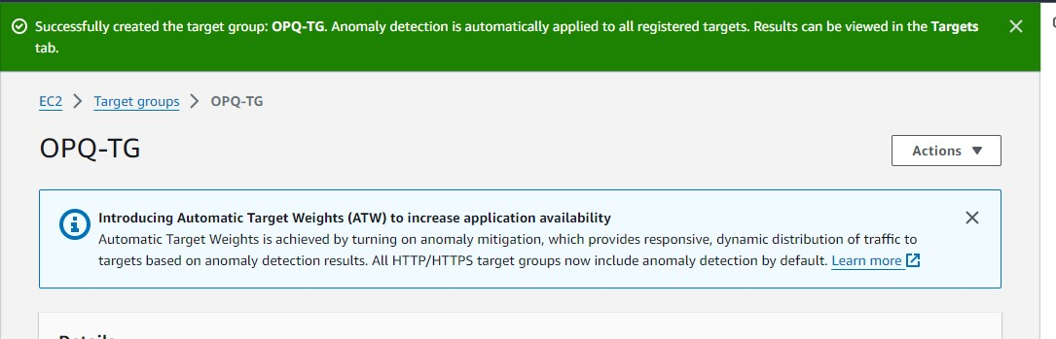

**5) Next got to Auto scaling group ..**

**A. Select ASG in that go to Load balancing select edit option…**

**B. below images shown clearly..**

**C. select option Add new load balancer..**

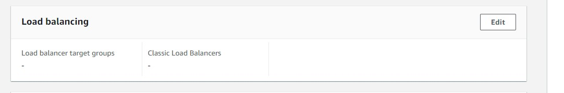

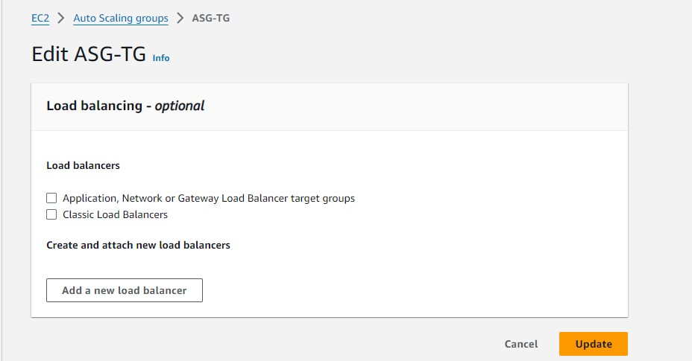

**6) Select application network in that field select existing TG in below image shown….And also add fields in Group size..**

**A. Next Update the ASG…**

**B. Successfully ASG will be updated..**

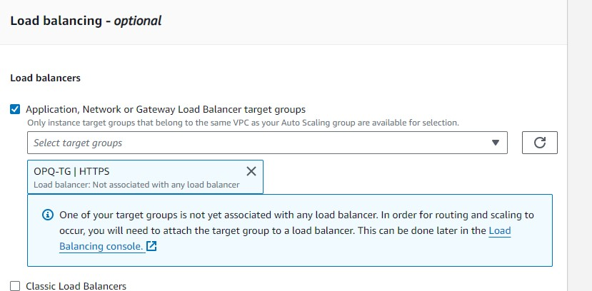

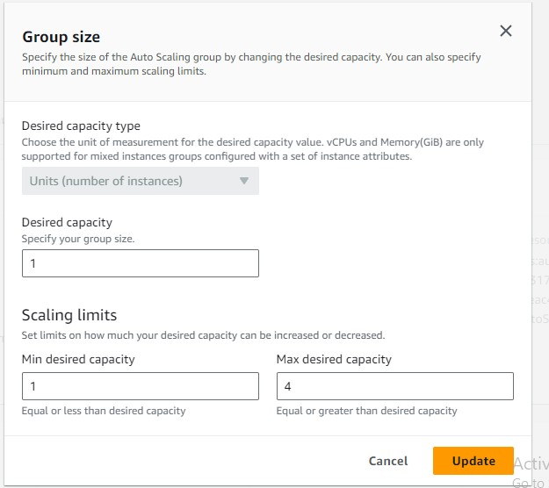

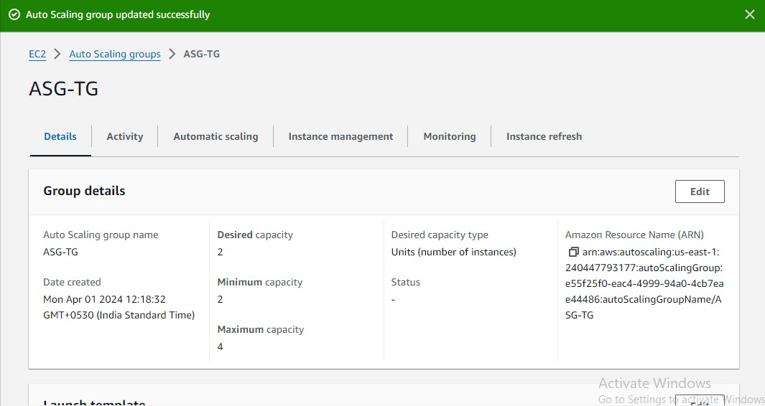

**7) Go to ASG select in that created ASG in that go to option Target to check health stauts…healty or unhealty…As shown in below images..**

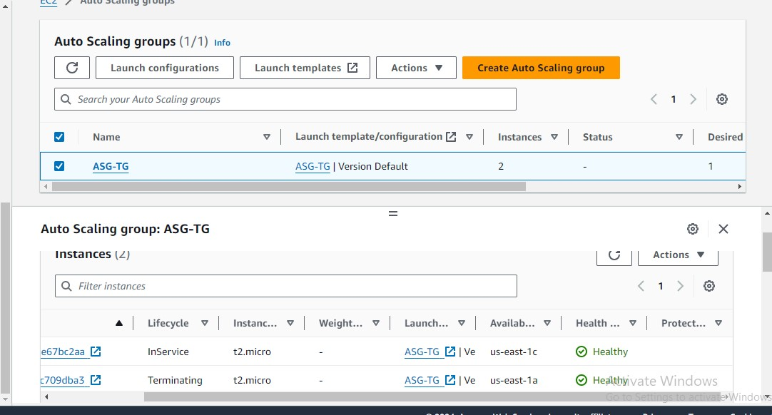

**8) Instance status found unhealthy….**

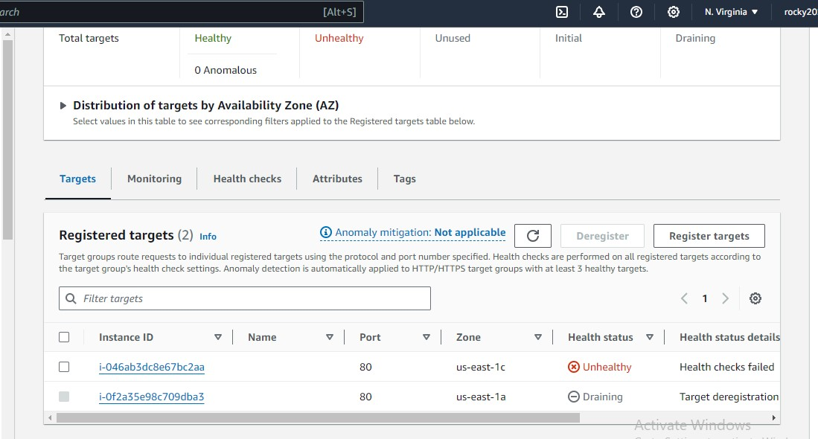

**END OF ASSIGNMENT…**